

ADDIS ABABA INSTITUTE OF TECHNOLOGY

School of Electrical and Computer Engineering

**Audio Spectrum Analysis**

**Name ID.**

**1.Amanuel Dagne ATR/5192/11**

Submitted to: Yiwab E.

**Abstract**

A Spectrum Analyser measures the amplitude or the magnitude of the input signal, with respect to the frequency. It is mainly used to analyse the amplitude of signals at different frequencies. A real time spectrum analyser doesn’t have any build time or lag. The algorithm that we will be using to convert the time domain signal to frequency domain is called FFT.

**Introduction**

The spectrum analyser is able to sample the incoming spectrum in the time domain and convert the sampled information into frequency domain. Spectrum analyzers tend to fall into two categories: so-called ‘swept’ spectrum analyzers and FFT-based spectrum analyzers. Swept spectrum analyzers work by using one or more notch filters (or mixers) to measure the signal amplitude at a given frequency, and by changing (or sweeping) the frequency of this filter a plot of amplitude against frequency can be constructed. Swept spectrum analyzers still have their place in high-frequency spectrum analysis, but for audio work they have the disadvantage that the signal must be constant for the whole period of the sweep.

**Algorithm Used**

The algorithm that we will be using to convert the time domain signal to frequency domain is called FFT. A fast Fourier transform (FFT) is an [algorithm](https://en.wikipedia.org/wiki/Algorithm) that computes the [discrete Fourier transform](https://en.wikipedia.org/wiki/Discrete_Fourier_transform) (DFT) of a sequence, or its inverse (IDFT). [Fourier analysis](https://en.wikipedia.org/wiki/Fourier_analysis) converts a signal from its original domain (often time or space) to a representation in the [frequency domain](https://en.wikipedia.org/wiki/Frequency_domain) and vice versa. The DFT is obtained by decomposing a [sequence](https://en.wikipedia.org/wiki/Sequence) of values into components of different frequencies. FFT-based spectrum analyzers work by digitizing the signal of interest using an analog-to-digital converter (ADC). The stored values are then processed using the Fast Fourier Transform (FFT) algorithm. The advantage of this method is that the spectrum of a one-off or short-duration event can be captured.

**Sampling Theorem**

The sampling theorem specifies the minimum-sampling rate at which a continuous-time signal needs to be uniformly sampled so that the original signal can be completely recovered or reconstructed by these samples alone.

**Audio Spectral Analysis**

Spectral analysis or Spectrum analysis is [analysis](https://en.wikipedia.org/wiki/Analysis) in terms of a [spectrum](https://en.wikipedia.org/wiki/Spectrum) of [frequencies](https://en.wikipedia.org/wiki/Frequencies) or related quantities such as [energies](https://en.wikipedia.org/wiki/Energies), [eigenvalues](https://en.wikipedia.org/wiki/Eigenvalues), etc. [Spectrum analyzer](https://en.wikipedia.org/wiki/Spectrum_analyzer), a hardware device that measures the magnitude of an input signal versus frequency within the full frequency range of the instrument.

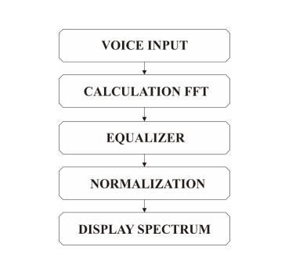

**System Design Steps**

1. Programming Language Used

Python is a high level interpreted, multipurpose programming language. Python is an interpreted language. This means that Python codes run on a Python virtual machine that provides a layer of abstraction between your code and the platform it runs on.

1. Software Required

* Microsoft Visual Studio C++ - Microsoft C++ Build Tools provides MSVC toolsets via a scriptable, standalone installer without Visual Studio.
* Microsoft Visual C++ 14.0

1. Libraries Required

* **PyAudio**PyAudio is another Python Library that can be easily used to play and record audio with Python on a variety of platforms.
* **MatPlotLib**Matplotlib is a library for Python and its numerical mathematics extension NumPy. It provides an object-oriented API for embedding plots into applications using general-purpose GUI toolkits like Tkinter, wxPython, Qt, or GTK+.

## **Installing Libraries**

* **pip install PyAudio -** to install the library used for receiving audio signals from the microphone. If you face any **problem installing PyAudio**, download the .whl file based on your Python version and system architecture from [here](https://www.lfd.uci.edu/~gohlke/pythonlibs/#pyaudio), and then run the command

pip install /path_to_whl_file/filename.whl

* **pip install matplotlib -** to install the library used for creating static, animated, and interactive visualizations in Python.
* **Numpy -** Numpy is a Python Library that adds support for large, multidimensional arrays and matrices. It has high level mathematical functions to operate on the data.
* **MatPlotLib -** Matplotlib is a library for Python which provides an object-oriented API for embedding plots into applications using general-purpose GUI toolkits.
* Fftpack.fft - SciPy offers the fftpack module, which lets the user compute fast Fourier transforms.

## **The Code**

*CHUNK*is the number of samples that will be processed and displayed at any instance of time.

*FORMAT*is the data type that the PyAudio library will output.

*CHANNELS* is the number of channels our microphone has.

*RATE*is the sampling rate. We will choose the most common one, that is 44100 Hz or 44.1KHz.

**Result**

The following spectrums were obtained for different audio inputs.

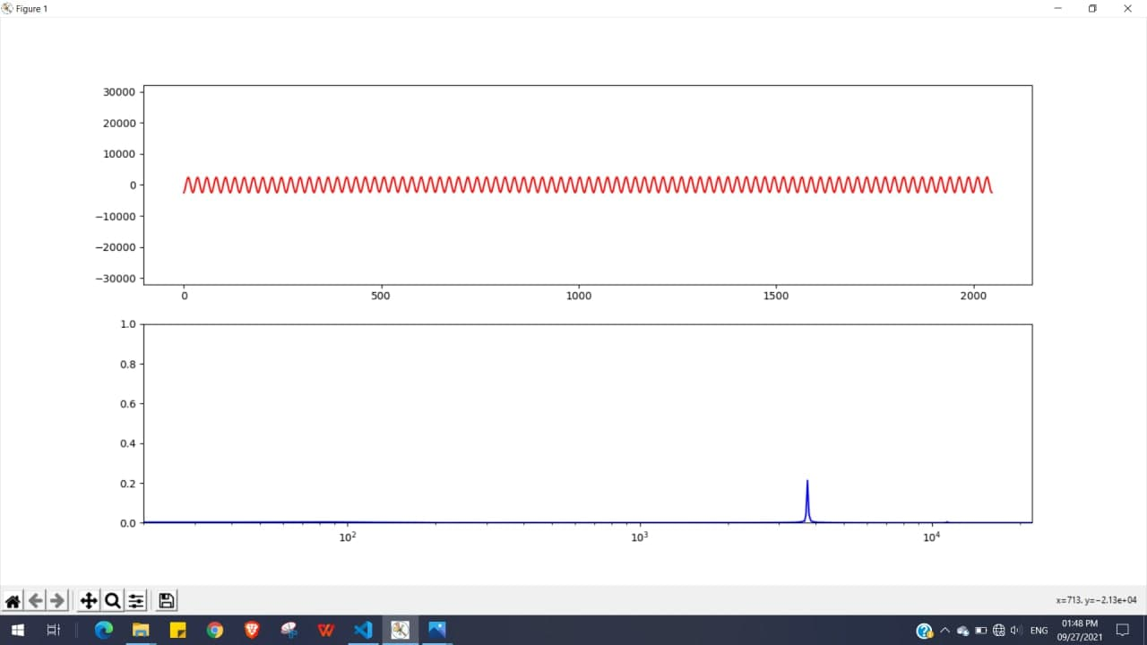

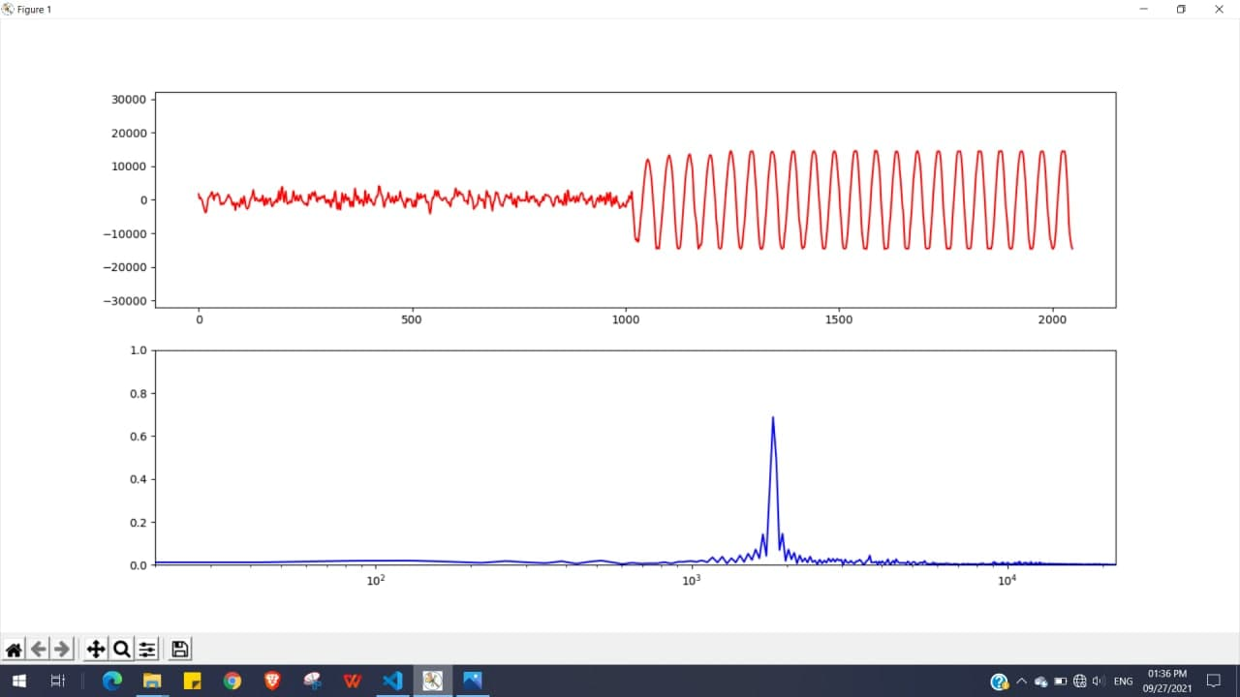

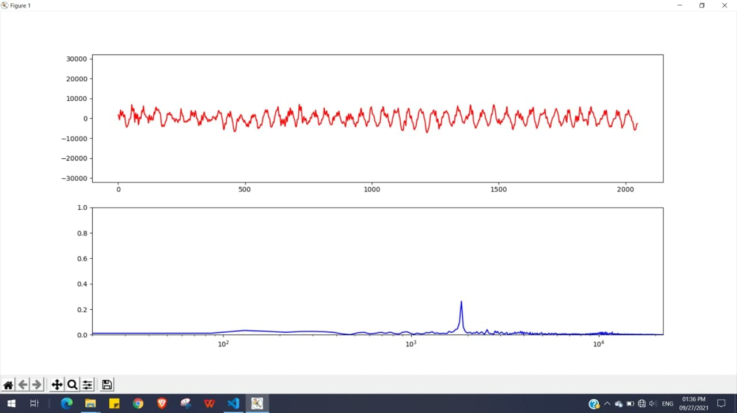

**Discussion**

This application starts with the creation of the Fast Fourier Transform (FFT) function, which calculates the amplitude value of the captured audio sound. Fast Fourier Transform analyzing, analyzes at a higher frequency resolution, allowing for precise fault pin-pointing and quality control. FFT analyzers can strain the capabilities of analog-to-digital converters. Real-time FFT analyzers offer good resolution and reduce sampling gaps.

**Conclusion**

The results of the audio spectrum analyzer indicate that the system can show the exact location of the audio frequency spectrum. An audio spectrum analyzer can easily measure very low amplitudes (as low as -120dBm), and high frequencies (as high as 150GHz). The audio spectrum analyzer measurements are in the frequency domain.

**References**

* <https://iopscience.iop.org/article/10.1088/1742-6596/1413/1/012005/pdf>
* <https://www.lfd.uci.edu/~gohlke/pythonlibs/#pyaudio>
* Python for Signal Processing - José Unpingco
* <https://en.wikipedia.org/wiki/Spectrum_analyzer>
* Stackoverflow.com